Step by Step Kit Instructions
**Before opening the kit, make sure you are prepared to stay in the room.**
- Go to the bathroom.
- Make sure you will not be interrupted (have the police taken their report if needed?)
- You want to have plenty of labels (roughly 1 sheet)
- A sharpie
- Paper bags
- Scissors
- Plenty of your size gloves
- A pen
- Tape
- (Most of these should be in the cart, but it is good to double check before you get started)
- A radio so you can get in touch with your resources when you need things.
Remember that you do not want your DNA to be all over in the kit. If you have a cold/respiratory infection wear a mask. Long hair? Put it up. Wash your hands often and wear gloves when handling the kit contents. (**TIP** If you get sweaty hands and find it difficult to change gloves frequently, wear a bottom pair of gloves, and change the top gloves)

Once you break the seals on the kit, you must stay with your kit. This is the only way you can testify that your kit has not been compromised (chain of custody).

It is helpful to work through the kit top to bottom (head to toe). In the order of the steps on the envelopes, with a few exceptions.

Grab a trauma table if you like, or the mayo stand. You can use a chuck pad on the table, then open the kit and put the lid next to it. You can keep your instructions and steps you are done with or need to come back to in the lid.

The kit has the instruction within it. Use these often and as needed.

Check the kit expiration. If the kit has expired, and there are no other kits available, remove the sterile water bullet and utilize an unopened vial of sterile water from the med room. Be sure to document on the paper chart (where it states notes or deviations from protocol that the kit was expired, the sterile water was removed and replaced with an unopened vial of sterile water. Be sure to only use sterile water as saline will crystalize and render specimens unusable.
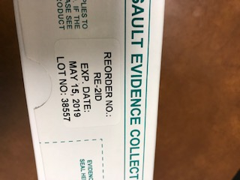
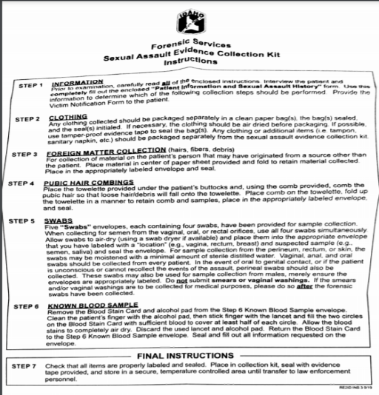
Expiration Date
KIT STEPS
This is the basic flow of the kit collection. Steps may be done out of order as patient care requires. For example, if the patient has not had anything to eat or drink in a while, you may jump to the oral swabs first in order to allow the patient to eat or drink during the exam. If the patient must go to the restroom, you may collect a urine prior to getting started for their comfort. If the patient must go to the restroom prior to the exam, encourage the patient not to wipe afterwards so you can collect good evidence on skin swabs later in the exam process. See number 13 for urine collection information.

- STEP 1 History
- Get a packet of paperwork out of the binder in the cart. Adult forms for age 14 and older or Post pubertal females. Pediatric form for any child under 14 or pre-pubertal females.
- Obtain consents after a decision has been made on what option the patient chooses from the options guide.
  - Note: Release of information and emergency contraception require separate consent. These are available in PolicyTech (the HUC can print them), if they are not already packaged with the paperwork.
- Gather the patient history.
- Start with the patient’s past medical history.
- Move onto the assault history.
- Ask any clarifying questions from the chart: force, impairment, type of contact.
- Gather post assault history.
- Utilize the assault history to guide your physical exam:
  - Where are you looking for evidence or injury?
  - What other concerns do you have? Strangulation, drug facilitated sexual assault? Etc.

- STEP 2 Clothing Collection
- Put a clean flat sheet on the floor near the patient’s bed.
- Take a chux, open it and lay it on top of the flat sheet.
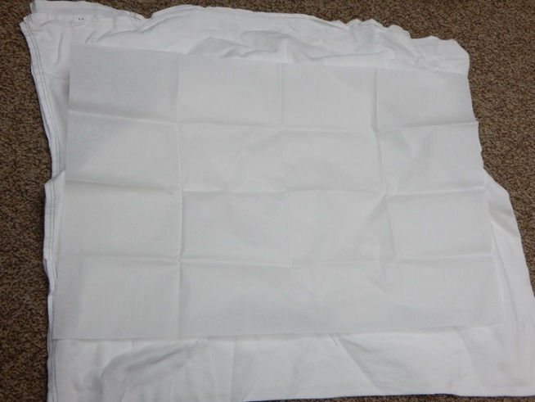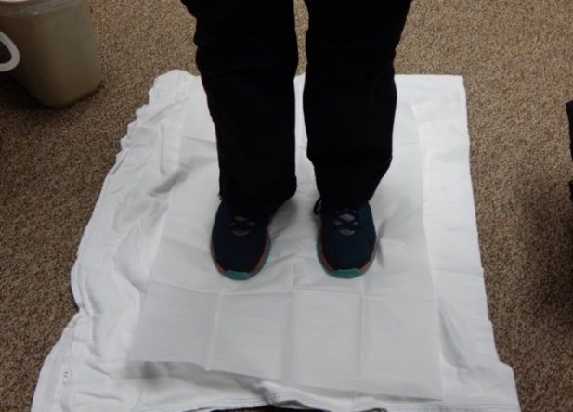
- Have the patient stand in the middle of the paper sheet and remove outer clothing while standing on the paper.
- Open brown bags and place them around patient.
  - Do not stick your arm inside the bag to open them. Try and open by pulling at opposite corners of the outside of the bag.
- Have the patient drop their clothing into the bags, if possible.
- Each piece of clothing needs to go into a separate brown paper bag.
- Don’t shake out clothes or cut through any existing holes or rips.
- Using a sharpie label each bag with contents example: “black t-shirt”.
- If the item is wet, also label as “wet” (if wet evidence, transfer to law enforcement ASAP)
  - If sopping wet, place in plastic bag and leave open. Place the plastic bag in a paper bag and seal paper bag, label the same as above with “wet”.
- Underpants are collected in all cases, even if outer clothing is not.
  - Consider collecting the item closest to genitals if the patient has changed.
    - This may not be underwear, this could be leggings, shorts, etc.
- Give the patient a gown and get in the bed.
- Fold the chux inward to capture any debris inside the sheet.
- Place chux in a paper bag, label “bindle”, place a patient label, date, time and your signature, and seal it with an evidence seal, sign across it.
HOW TO FOLD A BINDLE:

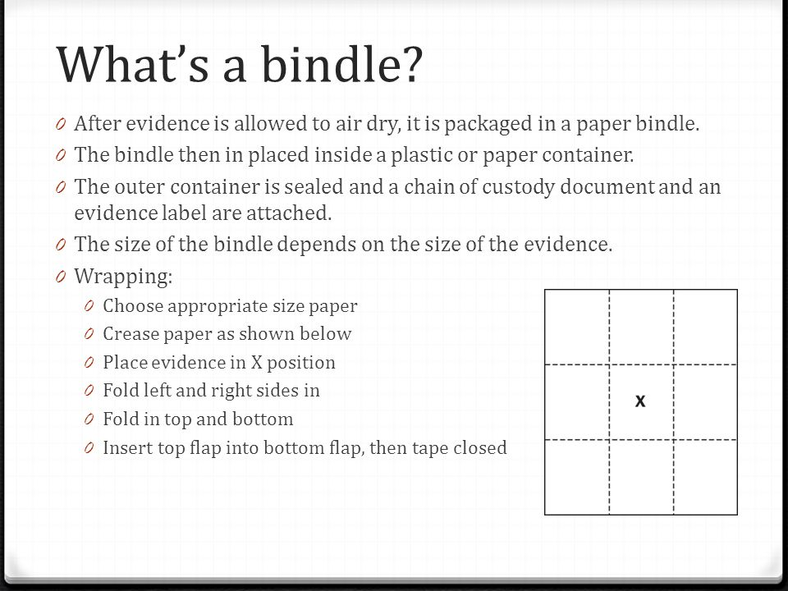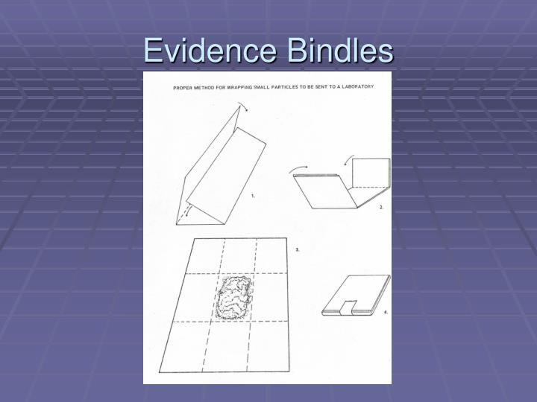

- Once the patient clothing is off and in individual bags, proceed to the next step to label and seal the bags.
- Seal the bag with an evidence label and sign across it.
- Tape each bag closed with 2” silk tape across the opening and around to the other side.
- Label bag 1 of 4, 2 of 4, etc.

***Remember to explain that any clothing sent for evidence will not be returned to them***

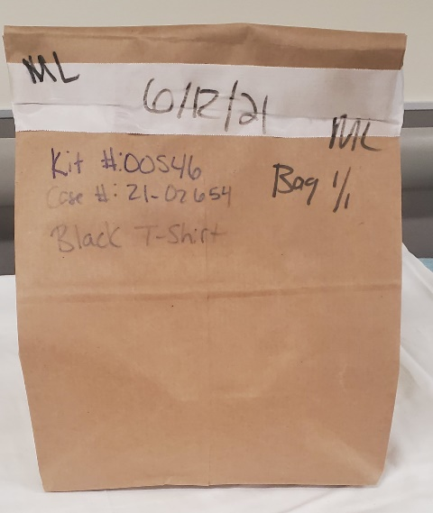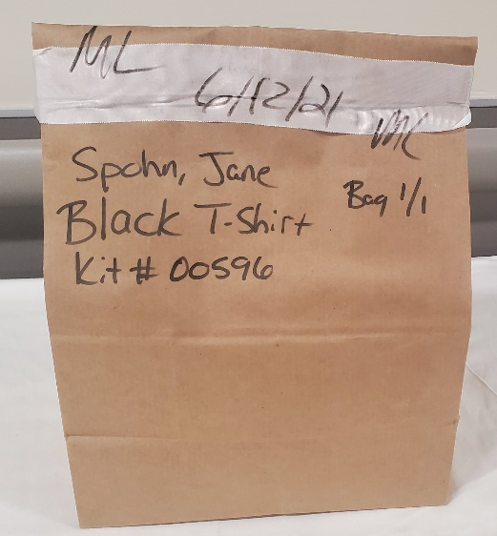
Use the case number and kit number in lieu of a name for the anonymous patient.

For the named patient, be sure to put the name and the kit number. You can also put the case number if you would like.

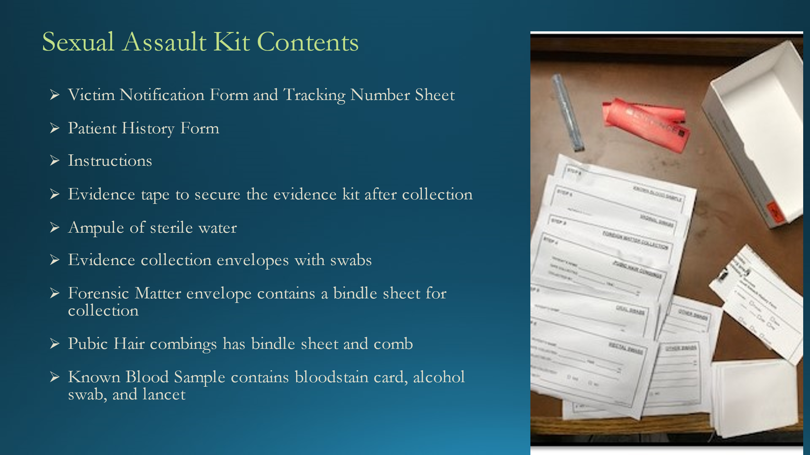

- STEP 3 Foreign Matter Collection (collect if debris visible)
- Unfold the provided paper sheet on a flat and clean surface.
- Use either a moist swab (one drop of distilled water on the swab tip) or wood end of swab, remove debris from patient’s body and place debris on paper sheet.
  - Can also be used to collect debris in hair.
- If debris adheres to swab, place swab in paper.
- Refold the paper inwards.
- Place the folded paper in the envelope.
- Label the envelope with patient label, date, time, and your signature.
- Seal envelope with evidence label, sign across it.
- Document on traumagram where debris collected from.

** NOTE STEP 5 CONTAINS ALL SWAB COLLECTIONS**

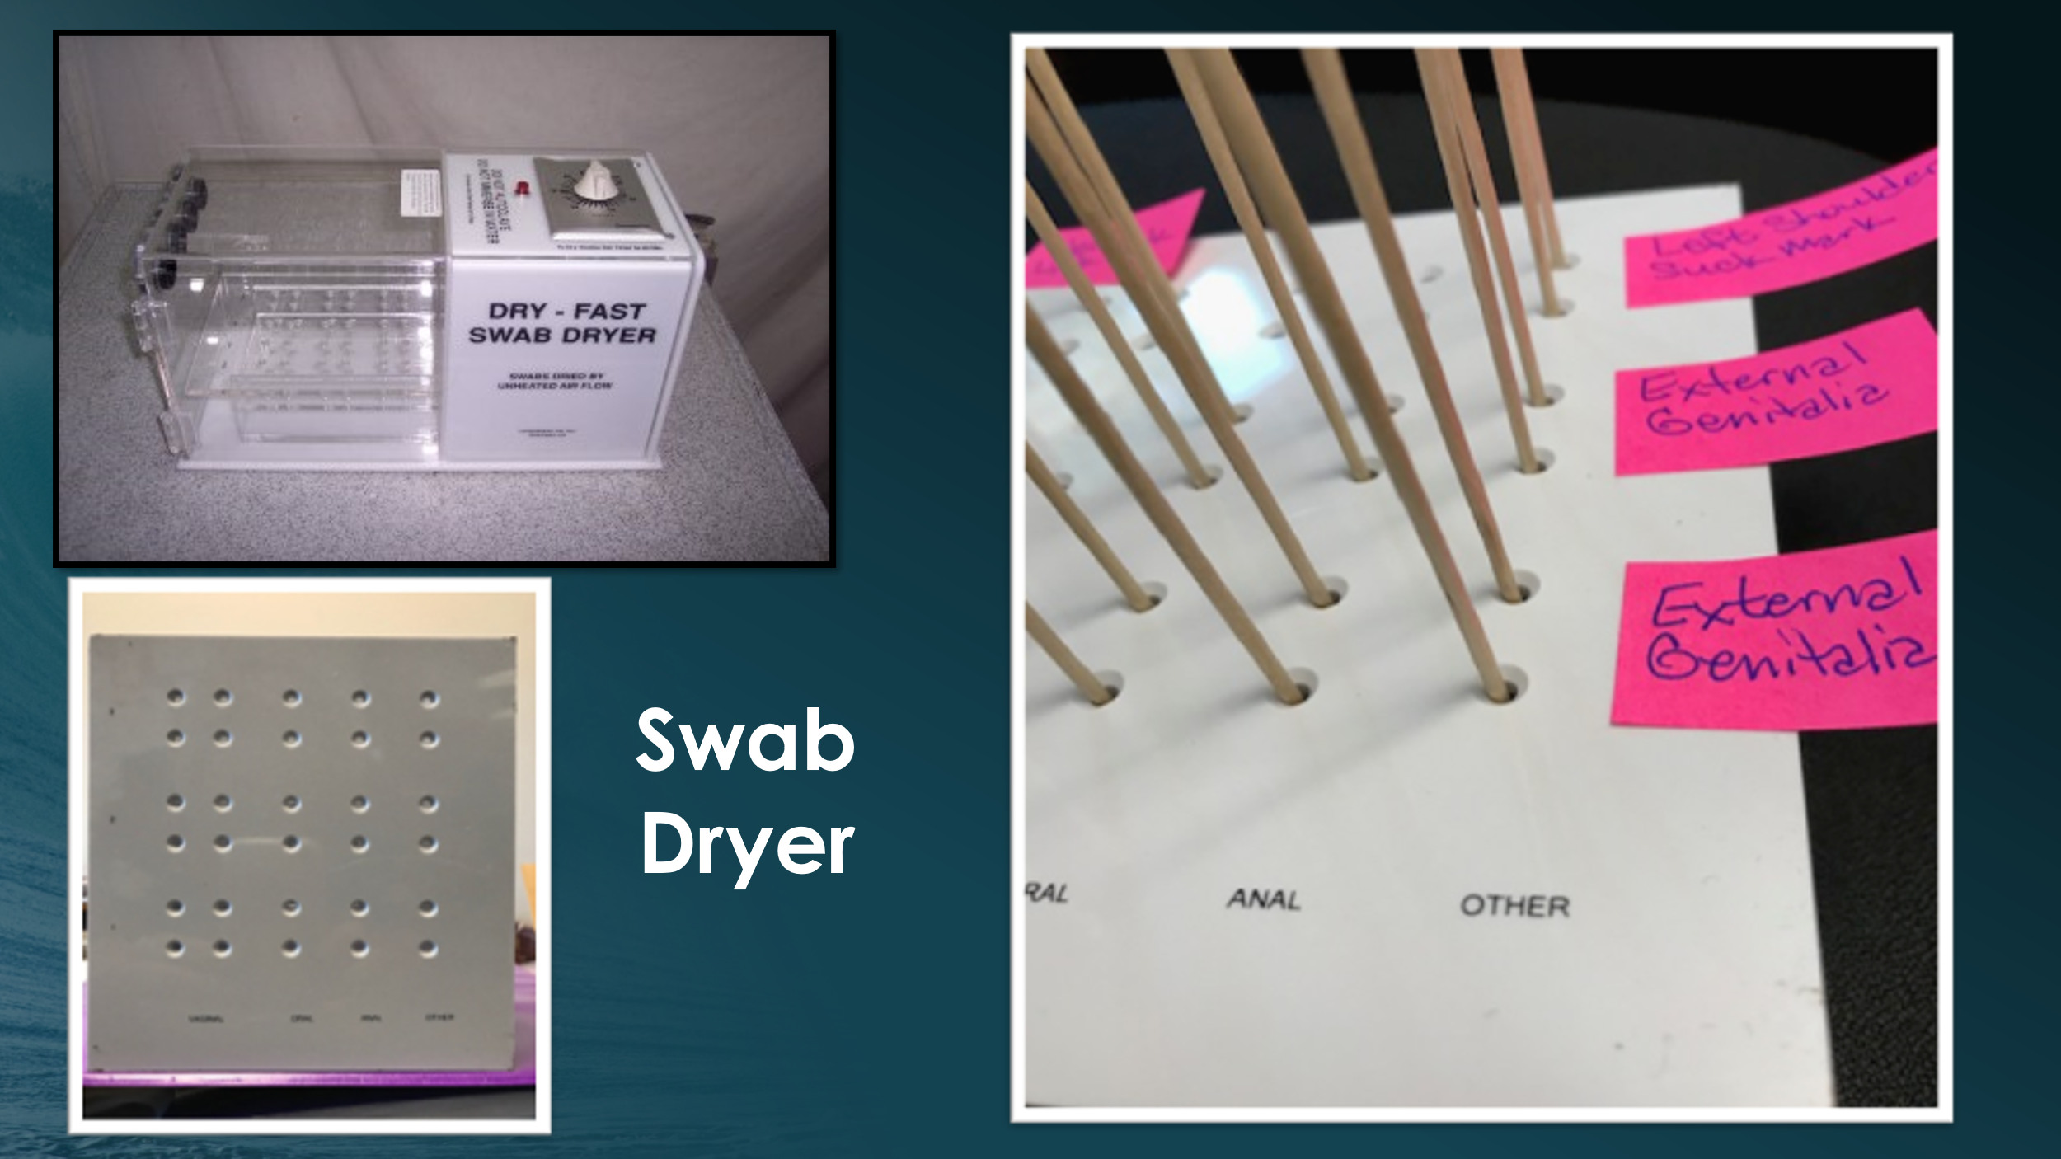

Utilize the dryer stand to allow swabs to dry for an hour. Dryer will not turn on as this is no longer recommended. Be sure to label where you placed your samples for later recollection and packaging. The dryer can be locked to maintain chain of custody. Be sure to always keep the keys on you. If you run out of holders in one dryer, there is a second lockable dryer you can use.
- STEP 5 Oral swabs (COLLECT IN ALL CASES)
- Obtain FOUR oral swabs:
- Collect two at a time.
- Swab gums around each tooth, under the tongue, and across the palette
  - “Oral” swabs are considered internal, unless otherwise noted.
- If patient reports oral contact and is chewing gum, collect that (in a sterile cup) as evidence, as DNA may have been captured in the gum.
- If history indicates swabbing outside of mouth (lips, etc.) collect as “other”.
  - Such as kissing, licking, or biting.
- Swab around piercings as they can hold DNA.
- Place in dryer stand and label where you placed the swabs.

- Step 5: Alternate Light Source (ALS)
- Utilize the ALS to look for potential body fluids on skin.
- Can also use on clothing when the patient does not want to part with items.
- Turn the lights down and wear the orange glasses with the blue light and the yellow with the UV light. (Instructions on front of ALS box)
- The light is found in the cart in a black box
- Document all sites of positive florescence (ALS+) on the traumagram in your documentation.
  - Document suspected fluid type if known.
- Swab sites of fluorescence as described in the following step.

- STEP 5 Other Swabs
- Collect when patient reports possible saliva, semen, lubricant, biting, kissing, areas of fluorescence identified above, or sites of aggressive handling (grabbed, pinched, forcefully held, forceful fondling, strangulation, etc), even if patient bathed prior to exam.
- For each skin site **each site goes in its own envelope! **
  - Moisten the tip of 2 swabs with distilled water provided, thoroughly swab site.
  - Put both swabs into swab dryer and label with body site location for later recollection.
- Repeat this process for each skin site, label traumagram on chart with site numbers and suspected specimen type (saliva, semen, epithelial, lubricant, etc.)
  - If you run out of envelopes, you can use the extra envelops out of the cart. Cross off site on the envelope and replace with site of collection and suspected body fluid.
  - Be sure to appropriately document any injuries noted on the skin assessment on the traumagram as well. Utilize injury labels and recommendations listed on charting to aid.

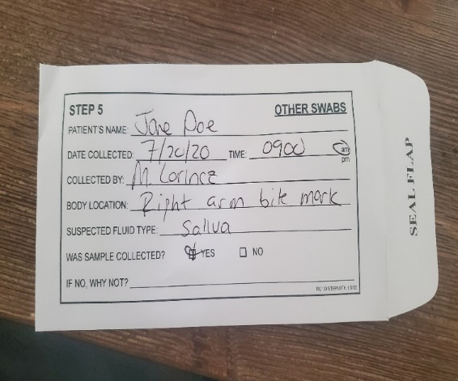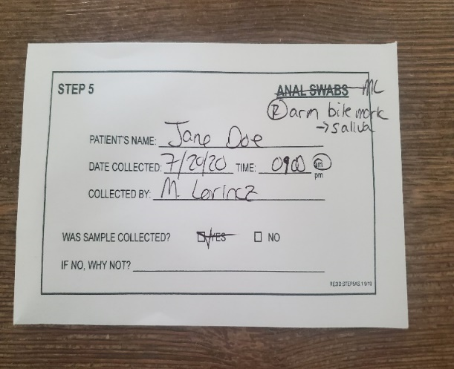

- STEP 4 Pubic hair combing (do not do if there is no pubic hair)
- Either you, or the patient can do this, but you must observe if patient does it.
- Patient should be sitting or lying with their legs out to the sides (frog legs).
- Unfold and place the paper under the patient’s buttocks.
- Using the comb provided comb the pubic hair in downward strokes so that any loose hair/debris will fall onto the paper.
- If there is matted hair, you want to clip those sections with sterile scissors and place that hair in the paper, then in the envelope (if the patient consents).
- Refold the paper inward with the comb in it and place it in the envelope.
- Label the envelope with patient label, date, time, and your signature.
- Seal envelope with evidence label, sign across it.

- STEP 5 External Genitalia (This portion of the exam can be done by the RN or the Provider during the collection of vaginal/endocervical swabs).
  - Female patients: Collect when patient reports contact to vagina, perineum, or anus by any part of the assailant’s body even if patient has bathed prior to exam.
- Moisten 2 swabs with distilled water provided.
- Use both swabs simultaneously to swab the genital folds and perineum. (See picture diagram below)
- These swabs should be labeled “external genitalia”.
- These swabs do not have their own envelope, utilize an “other swabs” envelope or one of the extra envelopes. (External genitalia envelope will be in all kits this fall).
- Prepubertal females: A speculum should NEVER be used!!!
  - These will be the only swabs collected.
  - We do not insert ANYTHING into the vagina.
**We do not use sedation for sexual assault exams**
- Males
- Shaft swabs – use 2 damp swabs and swab from glans to base of penis, entirely circling the shaft. (See picture diagram below)
- Do NOT insert swab into urethra!
- Scrotal swabs – use 2 damp swabs and swab entire scrotum (See picture diagram below)
- Do not divide the penis into ‘parts’ for swabbing – the entire penis is one specimen
- Document if male patient is circumcised, and any skin abnormalities.
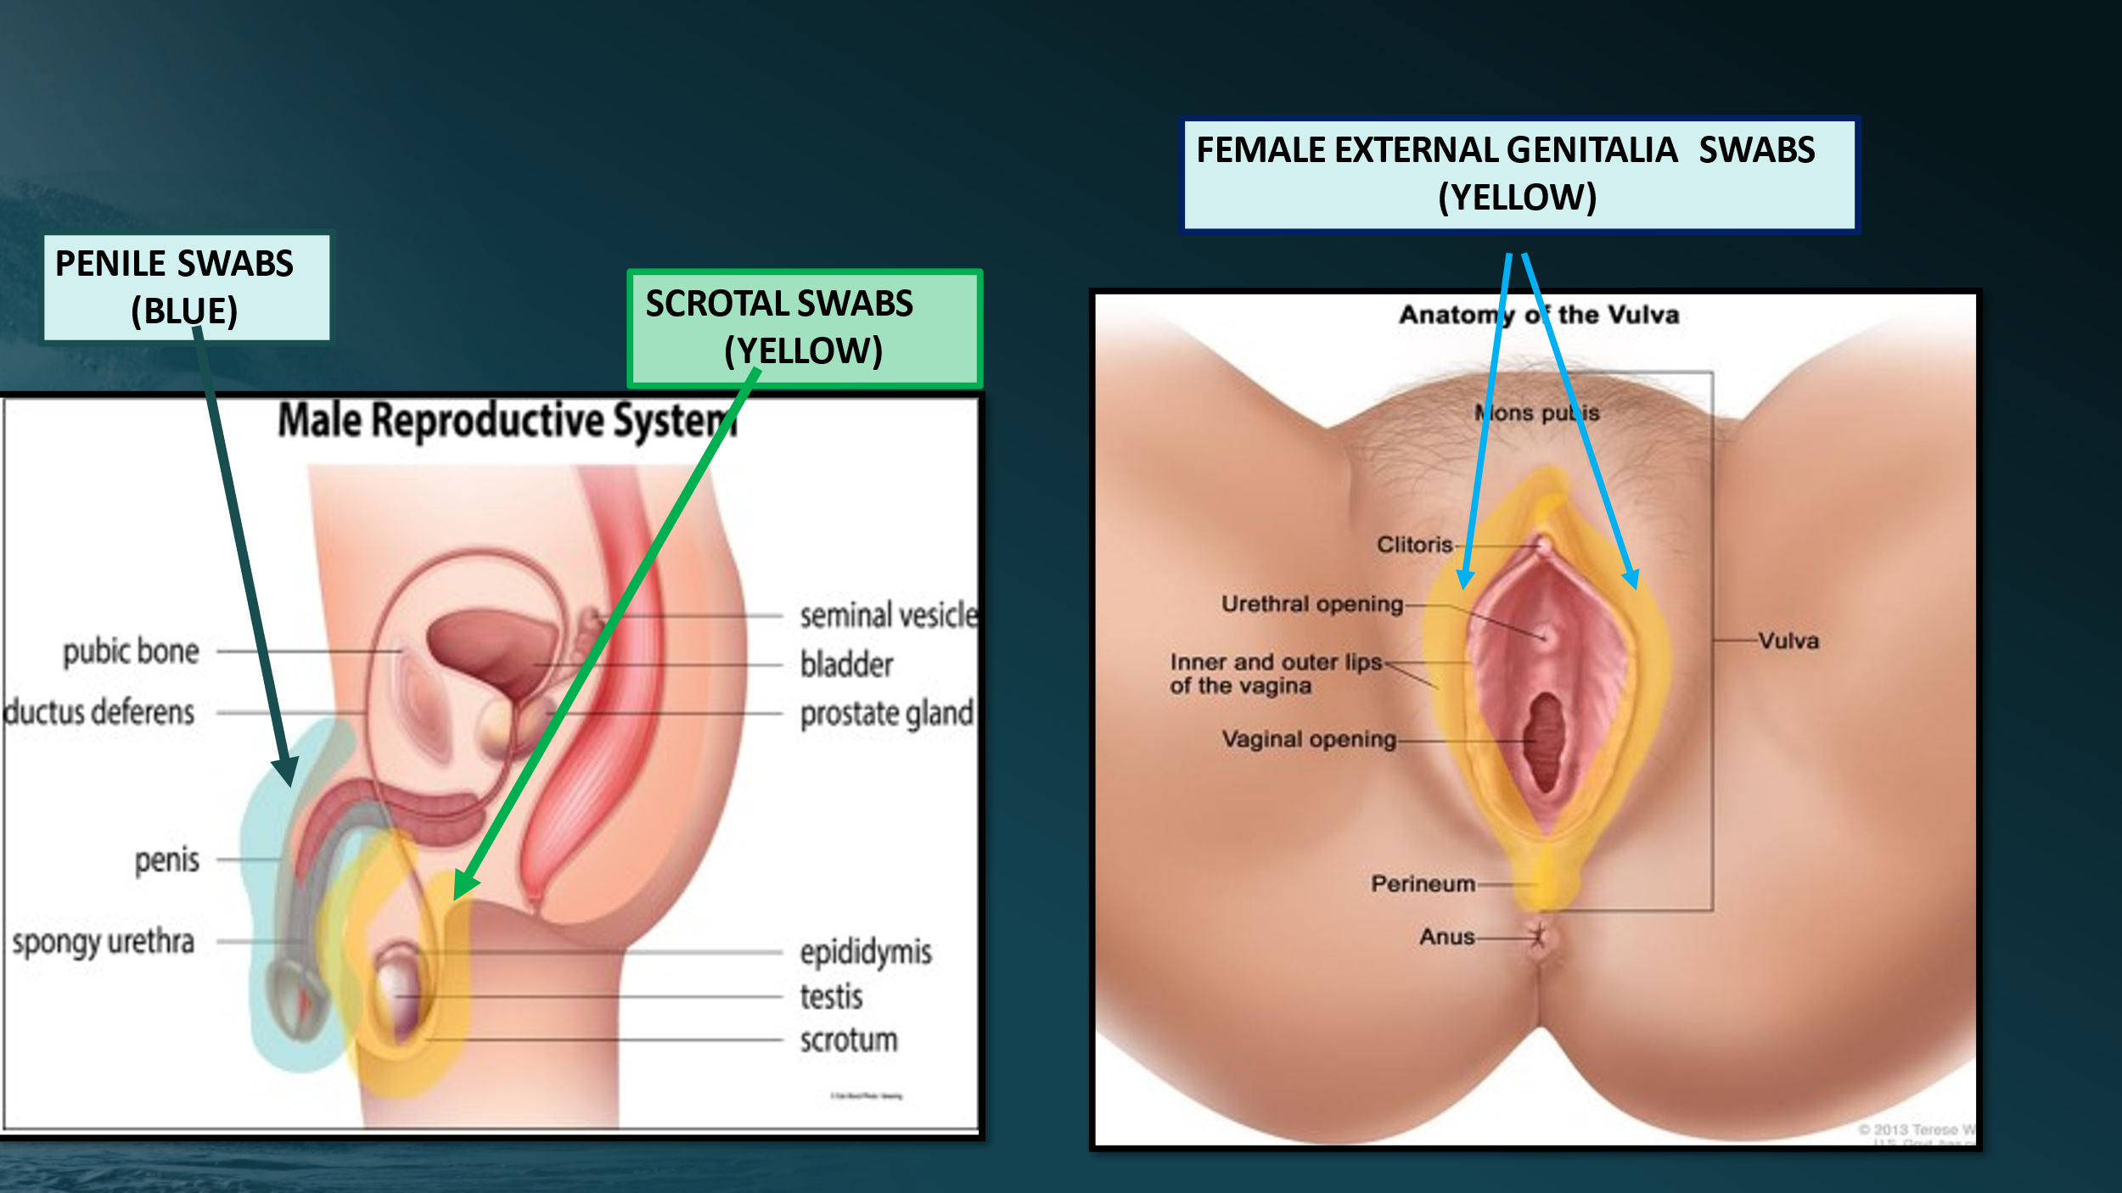
- STEP 5 Vaginal swabs **If not SANE trained, a provider does this part of the collection, with your assistance** ** SKIP IN PREPUBERTAL FEMALES**
- Collect when patient reports contact to vagina, perineum, or anus by any part of the assailant’s body or when clinician deems collection is appropriate.
**For young, elderly, or any patient for whom speculum use is uncomfortable, all 4 swabs can be collected from the posterior vaginal pool without use of speculum (blind insertion)**
  - Use total of four dry swabs, obtained two at a time, if possible
  - Gently set tip of 2 swabs into cervical os for 5-10 seconds (1 at a time)
    - Do not insert further into os or rotate.
    - Highly concentrated female DNA can overwhelm the male DNA.
    - After removing from os, roll swabs around outer cervix (gently!),
  - Run the second 2 swabs through the posterior fornix, then around entire vaginal vault.
  - Ensure any vaginal injury is swabbed (still counts as internal swab, not a separate swab)

- STEP 5 Anal swabs
- Collect when patient reports contact to vagina, perineum or anus by any part of assailant’s body.
**Encourage all patients to do anal swabs as gravity could pull evidence to the anal region**
- Use two swabs at a time, with 1-2 drops of sterile water on each swab.
- Collect sample by spinning/rolling around the anus and insert up to the dentate line.
- Collect from anal sphincter to approximately 1” around it externally, swabbing the skin folds
  - Repeat same for second set of two swabs, for a total of 4 swabs.
  - Document any injury and collect any foreign materials.
- Internal Anal Swabs
- Collect for reported anal penetration.
- Explain procedure to patient ~ especially that manual traction will be needed for sphincter relaxation for up to two minutes before swabs can be collected if anoscope is not used.
- Use supine knee-chest position (IF tolerated by patient!)
- Apply gentle bilateral traction to buttocks and wait for anal dilation to occur.
- Insert swab no further than one inch and rotate around the sphincter. (See picture diagram below)
- Label envelope as “internal anal swabs”
** use Anoscope if qualified to do so **
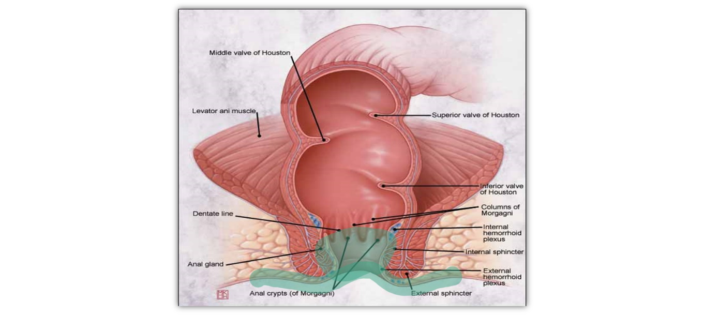
ANAL SWABS
(BLUE)
- Step 6 Known Blood Sample (COLLECT IN ALL CASES)
- Do not touch the reference blood card unless you have clean gloves on
- Fill the 2 circles at least half full.
- Do not use too much blood to fill the circles as you need to let the card dry.
- Place patient label on outside of reference card and allow blood to dry!
- Return dried card back to envelope (likely at the end of this whole process).
- Label the envelope with patient label, date, time, and your signature.
- Seal envelope with evidence label, sign across it.

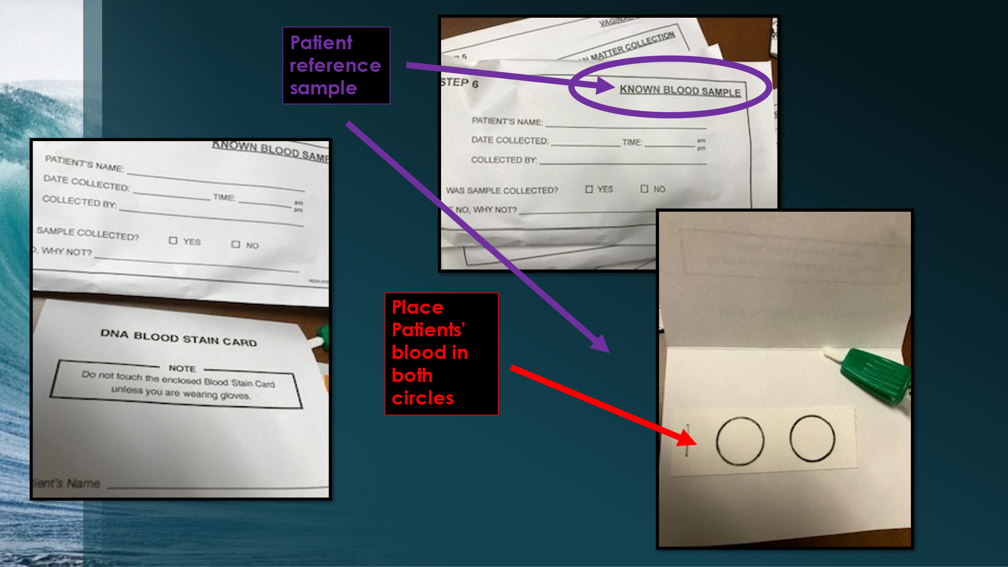

- Allow kit specimens to dry
  - While specimens are drying, address pregnancy and STI prophylaxis.
    - Utilize page 10 of the documentation and the SANE order set in Meditech to help.
  - Are there any other concerns such as Drug Facilitated Sexual Assault (DFSA)?

- Urine toxicology (COLLECT URINE anytime DFSA is suspected or if patient
admits to taking any drugs)
- This should be a dirty catch, you don’t want to wipe away potential evidence
- Split the sample between the cup going to crime lab and the rest into a cup for a pregnancy test.
- Label the urine container with a patient label, date, time, and your initials.
- Seal the container with parafilm around the top.
- Place the urine container and the paper towel into the biohazard bag.
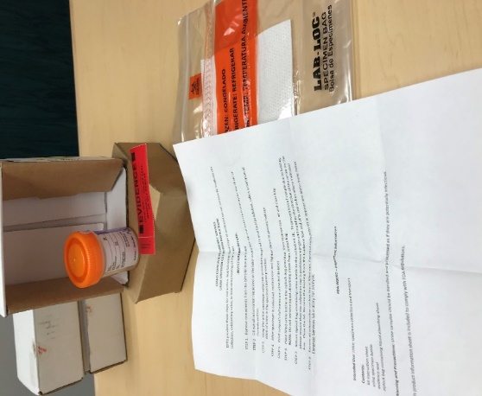
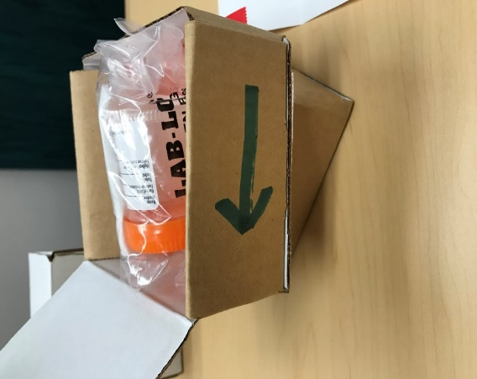

- Blood toxicology (only collected if suspecting drug facilitated assault within 24 hours)
- Utilize the gray tubes within the kit.
- Can collect blood to utilize for Known Blood Reference sample from number 11 above.
- You do not have to use the blood draw instruments included in the kit if you are not comfortable with it, but you MUST use betadine unless there is a patient allergy.
- Label the tubes with patient label, date, time, and your initials.
- Place tubes in a biohazard bag with the paper towel.

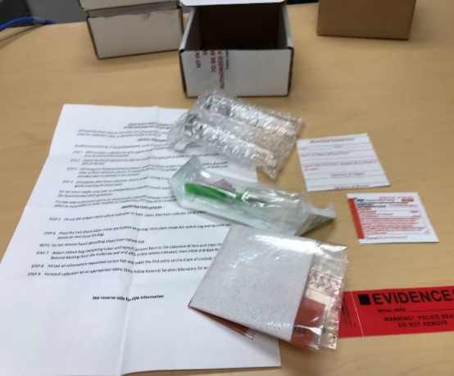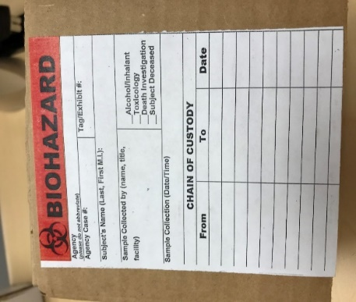
***Ensure chain of custody is filled out for both the Blood and Urine Toxicology**

- Assault History Form
- Fill out ISP Assault History form and return to kit.
- They only need a brief summary in order to prioritize which swabs have the best chance of potentially finding DNA.
- Make a copy for law enforcement if the patient is reporting.
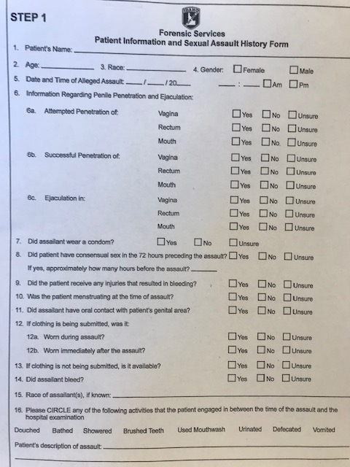
- Packaging
- Once swabs have dried for 60 minutes.
- Fill out envelopes as indicated.
- Place swabs in appropriate envelopes.
- Seal envelopes with patient label and sign.

- Kit reassembly
- Verify all the paper evidence bags with clothing/tampons, etc. are properly labeled, sealed, numbered in order, and signed.
- Ensure all envelopes are filled out correctly, sealed, and signed.
- Return all evidence envelopes back into kit.
- Return Patient History Form to kit.
- Remove the Victim Notification Form and keep for discharge.
- Take a moment to review the kit and be SURE you have everything that needs to be in the kit.

- Sealing your kit
When you have completed all steps, seal your kit as described below:
**Do not put blood or urine into your kit**
- Using enclosed red evidence tape, seal kit at indicated spots on the box.
- Label the top of your kit. DO NOT put the patient’s name on this kit if the kit is anonymous!
- Make a copy of your packet and place it in an envelope sealed.

- Now that I am done and my kit is sealed, what do I do with it?
- You have 2 choices:
- If the case was reported to law enforcement, call the law enforcement agency that filed the report and ask them to pick up the kit.
- If the case was NOT reported (anonymous kits), See below under header “What to do with an anonymous kit:”
- How to maintain chain of custody for Kits going to Law enforcement:
  - You can lock your kit in the cabinet above the Phamacy Tech awaiting arrival of law enforcement HOWEVER, you MUST carry the key on your person until you turn the kit over. (Keys are in top drawer next to the charge nurse.)
  - If you need to leave, sign the kit over to the charge nurse or another SANE. Fill out the front of the kit and give the keys to the person you are signing the kit over to. This person will then be required to sign the kit over to LE or to repeat the process signing the kit over to the next charge or SANE.
- What to do with an anonymous kit:
Anonymous kits will be given to the agency with jurisdiction (or your best guess).
- DO NOT put patient identifiers on the outside of the box if this patient chooses anonymous! The kit will be tracked by the Idaho tracking barcode ONLY.
- Log your kit in to the logbook under the anonymous section.
- Make sure you get a case number from LE and enter it in the logbook as well.
- Call the appropriate jurisdiction for kit pick up.
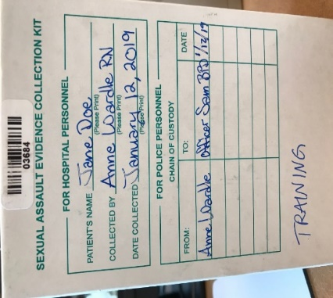
- Finishing documentation
  - Ensure you have completed all documentation
  - Fill out page 10 as indicated. Note any deviations on the documentation. Did you need to use sterile water due to the kit being expired? Did the patient decline portions of the exam?
  - Document the evidence collected and transferred to LE as indicated.
  - Document the kit number where indicated on page 10.

- Handing off the Kit. (To another RN or Law Enforcement).
- Maintaining Chain of Custody
- Fill out the first line under “For Police Personnel” chain of possession.
- The RN who is handing off the kit, puts their name on the “Received from” line with date and time.
- The person receiving the kit (RN/LEO) will sign their name on the “Received by” line along with date and time.
- When signing kit to law enforcement, be sure to get the case number.
- Document the name of the LEO and the agency on page 10 where indicated. If you have already submitted the paperwork to the HUC, you can document this as a note in the chart.
- Make a copy of the paper chart and place in an envelope with the kit number on the front of the envelope for law enforcement if the patient is reporting.
NOTE: Only do this AFTER you seal the kit.
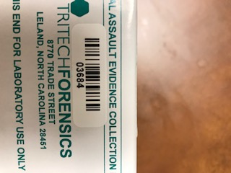
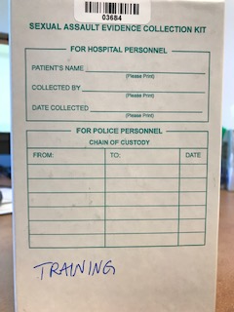
Kit Tracking Number
Chain of Custody
**Make sure you have noted the kit tracking number for tracking in the system**

- Kit Tracking
  - See SANE logbook for Jane’s log in information and the web address inside the front cover of
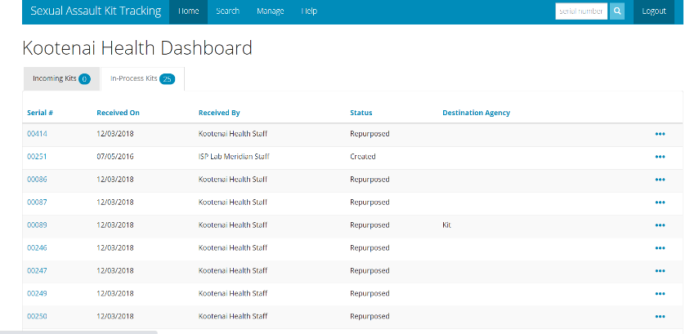
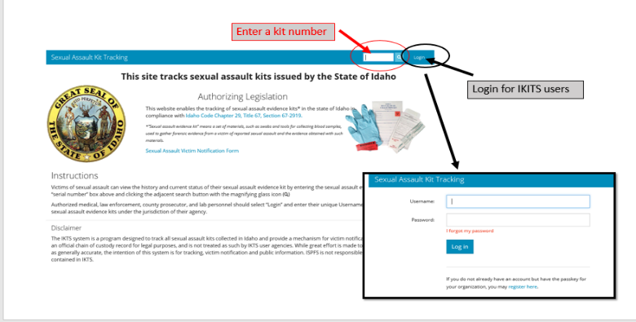
  - Send the kit once LE picks up the kit. You may need to backdate the collection date.

  - In the top right corner, enter the kit number (found on the kit).
  - This will pull up the kit summary.

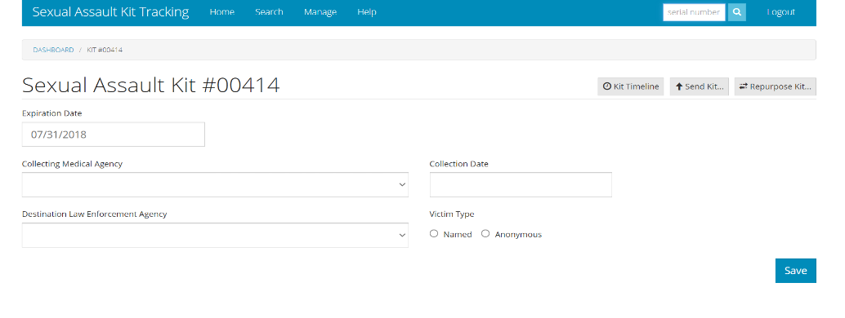
  - Fill out the information and hit save.
  - After you hit save, click send kit.

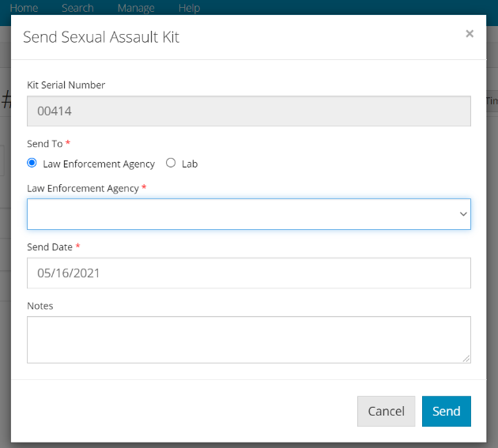

- Fill out information.
- In notes section, put the name of the nurse that collected the kit.

