**For Technical questions or capabilities contact:**

GRCO Marc Camin

Phone: 208.846.7526

[marc.camin@isp.idaho.gov](mailto:marc.camin@isp.idaho.gov)

Future Enhancements:

* Cellular Hot Spot / Extender
* MAST camera video feed distribution

Capt. Kevin Haight

700 S. Stratford Dr. – Bldg. 7

Meridian, ID. 83642

Phone: 208.846.7555

Fax: 208.846.7520

[kevin.haight@isp.idaho.gov](mailto:kevin.haight@isp.idaho.gov)

Maj. Kevin Hudgens

700 S. Stratford Dr. – Bldg. 1

Meridian, ID. 83642

Phone: 208.884.7205

[kevin.hudgens@isp.idaho.gov](mailto:kevin.hudgens@isp.idaho.gov)

The Idaho State Police thanks you for the opportunity to partner with your agency in providing public safety to the citizens and guests of our great state!

Request Form:

www.isp.idaho.gov/communications/current/

Idaho State Police

Mobile Command Center

For planned-event scheduling or deployment contact:

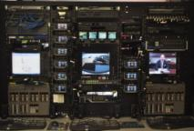

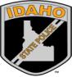

# Mobile Command Center

*Statewide Availability*

**Idaho State Police**

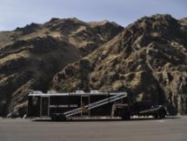

#### Future Enhancements

Idaho State Police Mobile Command Center

Emergency Deployment - ISP Dispatch:

208.846.7550 or 208.209.8730

# Current Notable Equipment

* 2015 Ford F550 Crew Cab
* 100 gallon diesel slip tank
* 9 Harris Unity quad band radios
* 1.8 meter satellite receiver
* 20 KW diesel generator
* 100 gallon fresh water tank
* 30’ hydraulic mast
* 340° mast camera
* 4 fixed mount cameras
* 3 UPS – battery back ups
* 6 VOIP phones, Satellite TV for news & weather
* Magnetic whiteboards
* Remote Audio Integration via ACU Link
* Remote Video Conferencing
* Audio Recording
* Drone Connectivity

The rear of the trailer houses the generator and hydraulic mast.

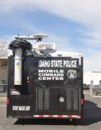

RCS Kristin Jacobson dispatching from a workstation.

The MCC can be utilized for pre-planned events, emergency situations, natural disasters, or crime scenes, where on-site command and control are needed.

The MCC is based in Meridian and can travel statewide without a need for commercial fueling stops, to enhance response time.

# What does the MCC do?

The MCC is a Type 2 FEMA response trailer. It is used as a communications asset as well as a coordination center. It has 9 Harris Unity radios, which allows for communications amongst VHF, UHF, 700 MHz, and 800 MHz users. It has availability for statewide response. The MCC can work off the grid where there is no power or cellular network coverage. The MCC has access to ISP’s Tiburon CAD system as well as VOIP network. It can also access the State of Idaho ILETS interface through CPI OpenFox.

# How was the MCC acquired?

# ISP received a Homeland Security grant in 2004 to design and purchase the MCC trailer. Delivery occurred in 2006 and it has been in service since that time.

# What does the MCC bring with it?

The MCC is transported by Class A CDL drivers, who are also able to operate the MCC. Additional dispatchers can also be requested to further enhance dispatch operations. It has a self-contained bathroom facility as well as a small kitchenette area that includes a fridge, microwave, sink and coffee maker. The main work area has a 12’ slide out work area as well as an additional computer workstation and all-in-one printer. The rear of the MCC contains a conference room that has a large screen monitor and its own independent exterior access.

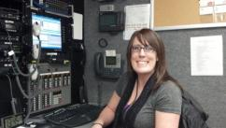

#### MCC Facts